Name: Mark Bryan Mantilla Date: April 16, 2026
Course/Yr/Sec: BSIT 3-A

Project Title: “Design and Development of a Web-Based Mantilla Funeral Reservation System”

Problem Statement
Many funeral service providers, including Mantilla Funeral Services, still rely on manual processes such as phone calls, walk-in inquiries, and paper-based records to manage funeral reservations and service scheduling. These traditional methods often lead to scheduling conflicts, delayed responses, difficulty in tracking reservations, and inefficient management of client information. During emotionally sensitive times, families may experience additional stress due to unclear communication and the lack of a convenient system for arranging funeral services. Furthermore, manual record-keeping increases the risk of lost or inaccurate data. Therefore, there is a need for a web-based reservation system that can streamline the scheduling and management of funeral services, provide organized records, and allow clients to conveniently reserve services online.
Project Objectives
The main objectives of the proposed system are:
- To develop a web-based platform that allows clients to view available funeral services and make reservations online.
- To implement an organized scheduling system that prevents service conflicts and double bookings.
- To create an administrative dashboard for managing reservations, services, and client information.
- To store reservation and client records securely in a centralized database.
- To improve service efficiency and provide a more convenient reservation process for clients of Mantilla Funeral Services.
Target Users
The proposed system will be used by the following users:
- Clients / Family Members – Individuals who need to reserve funeral services, view service details, and manage their reservations.
- Funeral Service Administrator / Staff – Personnel responsible for managing reservations, scheduling services, maintaining records, and monitoring service availability.

System Scope
Included in the System:
- Online funeral service listing with details (type of service, schedule, price, and inclusions)
- Client account registration and login
- Online reservation form submission
- Reservation approval and scheduling system
- Admin dashboard for managing services, reservations, and clients
- Centralized database for storing reservation and client information
- Basic reports such as service schedules and reservation records
Excluded from the System:
- Online payment gateway integration (for the initial version)
- Mobile application development (system will be web-based only)
- Integration with external funeral service platforms
- Advanced financial accounting features
- SMS notification system (may be considered in future upgrades)

UML Diagram (Use Case Diagram)
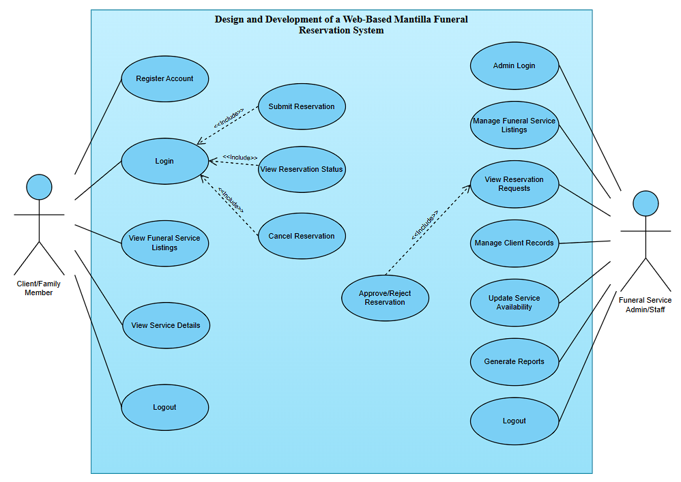
The Use Case Diagram illustrates the interactions between the actors and the Web-Based Mantilla Funeral Reservation System. It shows two primary actors: the Client/Family Member and the Funeral Service Admin/Staff. The Client/Family Member can register an account, log in, view funeral service listings and details, submit and cancel reservations, check reservation status, and log out. Meanwhile, the Funeral Service Admin/Staff manages the system by logging in, managing funeral service listings and client records, reviewing reservation requests, approving or rejecting reservations, updating service availability, generating reports, and logging out. Overall, the diagram presents the main functionalities of the system and how both users interact with it to facilitate and manage funeral service reservations efficiently.

